# Read object from file

1.Introduction

*2 most popular class type: InputStream, ObjectInputStream

2.Detail

2.1 InputStream class

*Read each small byte

2.1 ObjectOutputStream class

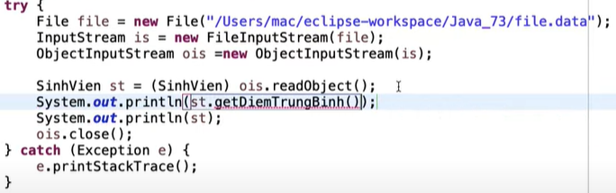

Write method

